Scanning with ORM Stack

Contents

1.Introduction 3
2. Workflow diagram to deploy the stack 3
3. Create Stack 4
4. Create vulnerability scanning 5
4. Plan the Job 6
5. Apply the Job 7
6.Verify in the Console 8
7. Destroy the job 10

1.Introduction

The Vulnerability Scanning Service agent inspects the host's operating system for installed packages and compares installed components to several open source vulnerability databases. It identifies open ports on the host and validates industry-standard benchmarks defined by the center for internet security (CIS), specifically the benchmarks that cover Linux authentication and access. A recipe determines the types of security issues that you want scanned.
Vulnerability Scanning Service scans targets based on the schedule and scanning properties in the recipe assigned to each target. Use vulnerabilities reports to identify security issues in targets like critical OS patches.

Pre-request:
1. Before configuring host scanning, administrator must create policies that allow the service to access host resources and then allow administration group to manage the scanning resources.
Example user group policy:
Allow group SecurityAdmins to manage vss-family in tenancy
2. Provide the Scan receipe ocid for creating Host Scan Target.

2. Workflow diagram to deploy the stack

Below diagram shows how the Terraform Artifact are applied in the OCI. While
creating a ORM stack, using terraform deliverables Init, Plan and Apply is the flow to provision the resource in the OCI. We can have the deliverables in any of below.
- Git Lab/GitHub Repo
- Bit bucket
- Can be in folder/.zip in the local disk
- Object Storage Bucket
- Can be in compartment
- Oracle provided Template

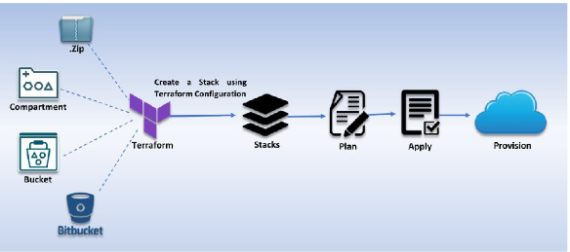

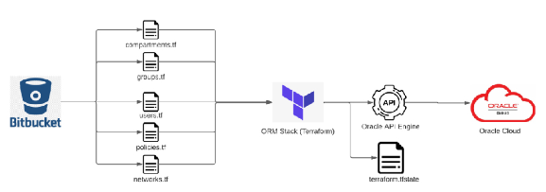

3. Create Stack

Go to OCI Console Developer Services Resource Manager Stacks select the compartment Create Stack

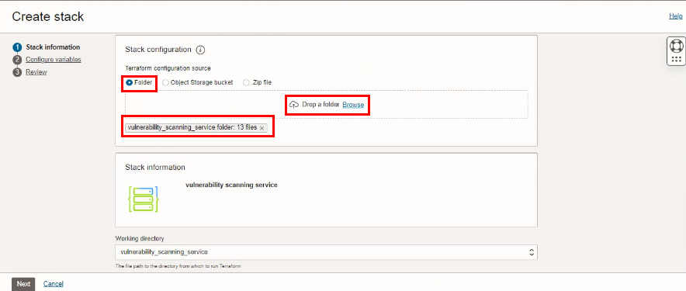

Select the “Vulnerability_scanning_service” folder that contains the terraform and yaml Upload

4. Create scanning

Select the parameters as per the below screen,

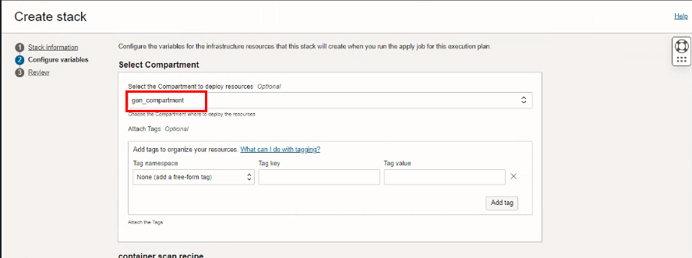
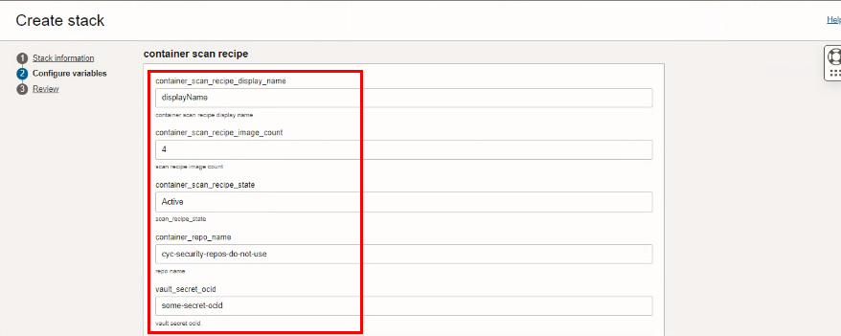
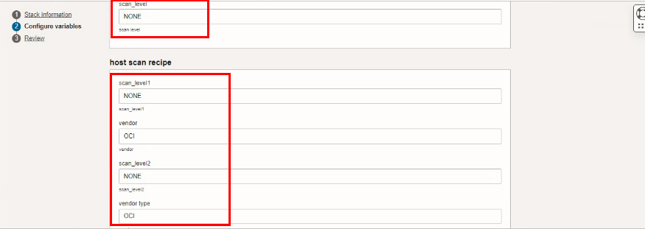

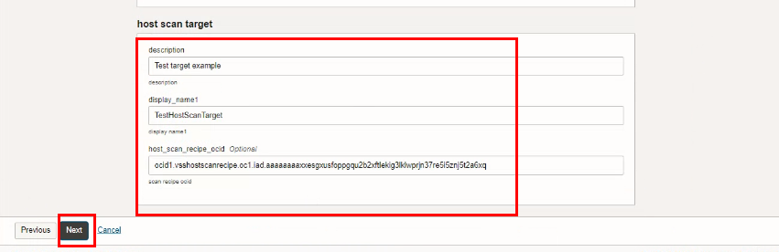

Click Next

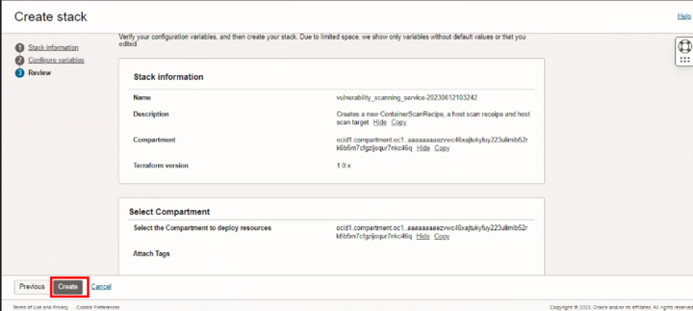

Click “CREATE”

4. Plan the Job

Click the “Plan”

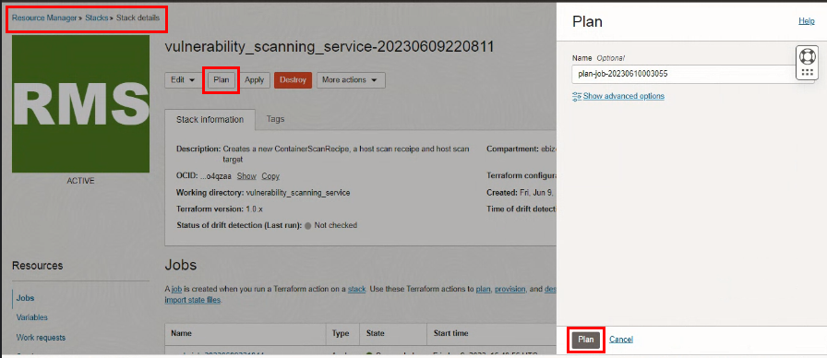

Verify the Plan is successful.

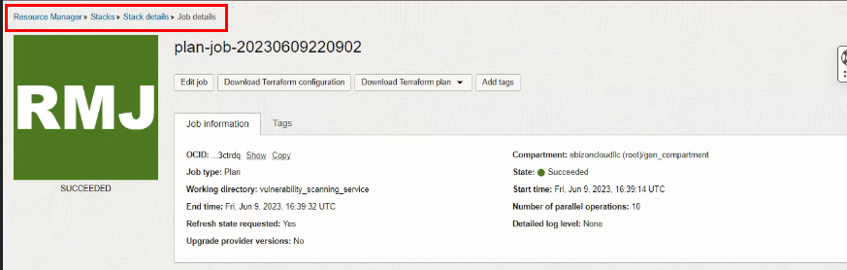
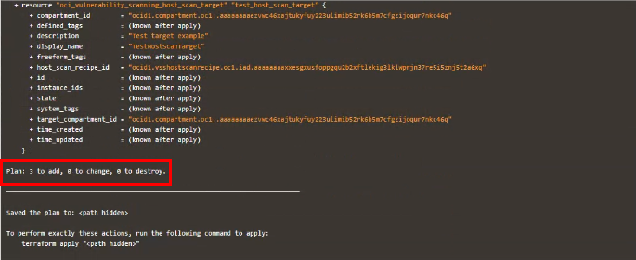

5. Apply the Job

Once the “plan” is success, now click “Apply”

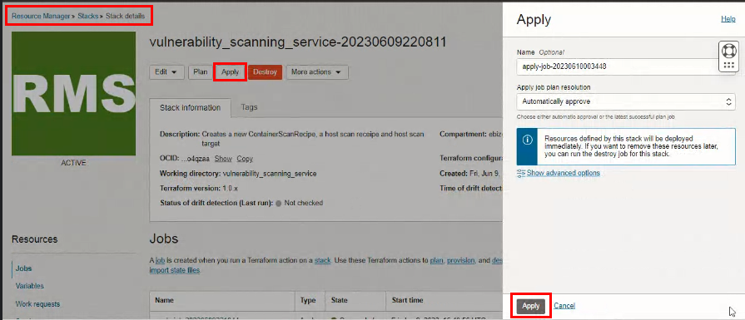

Verify the Apply is successful.

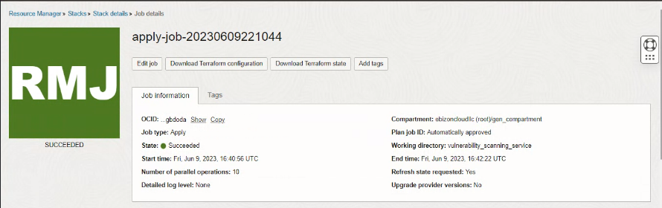
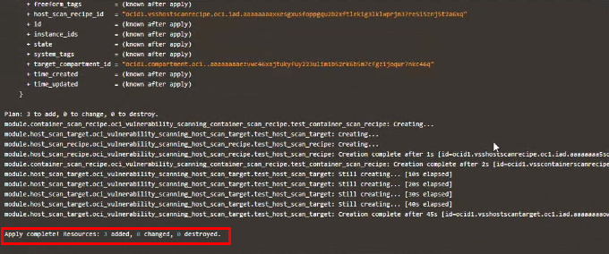

6. Verify in the Console

Go to OCI Console Identity&Security Scanning Scan RecipeHosts

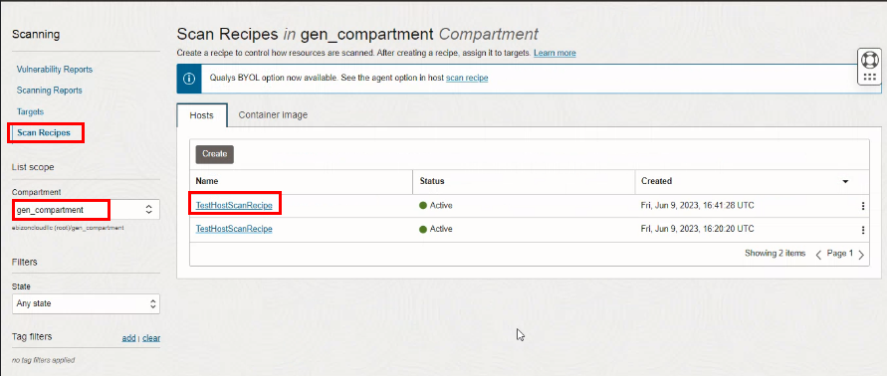

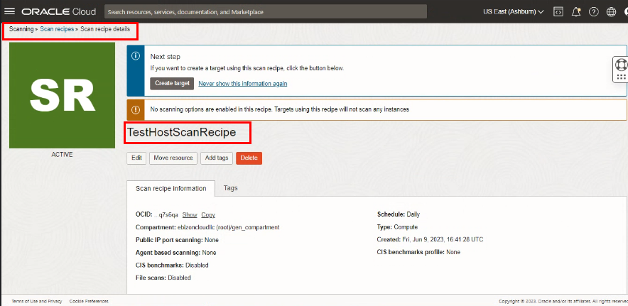

Go to OCI Console Identity&Security Scanning Scan Recipe Container image

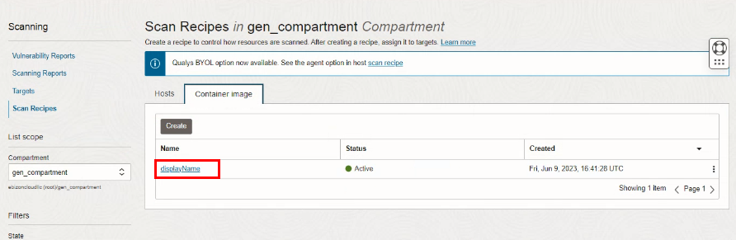
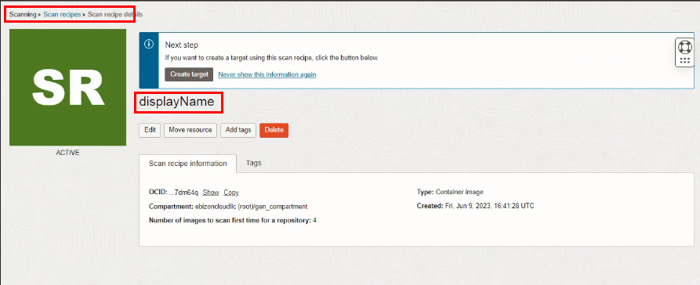

Go to OCI Console Identity&Security Scanning Scan TargetHosts

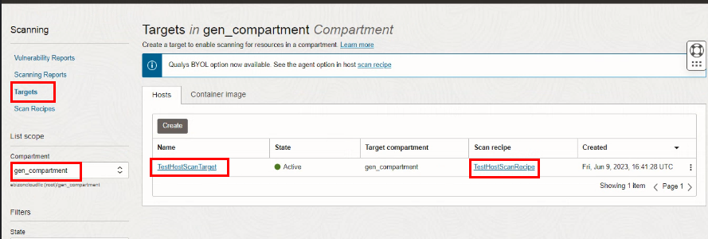
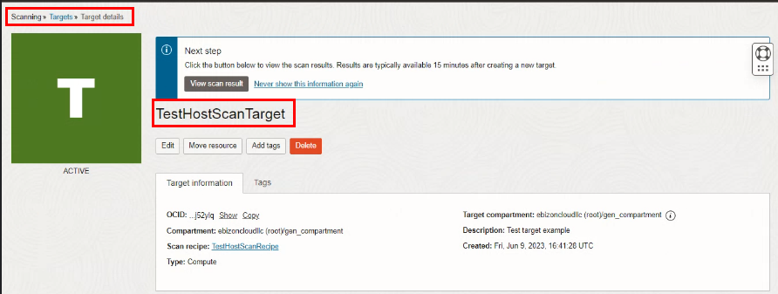

7. Destroy the job

Create a destroy job in Resource Manager to release resources associated with a stack and clean up the tenancy. Once destroyed data cannot be recovered from resources.

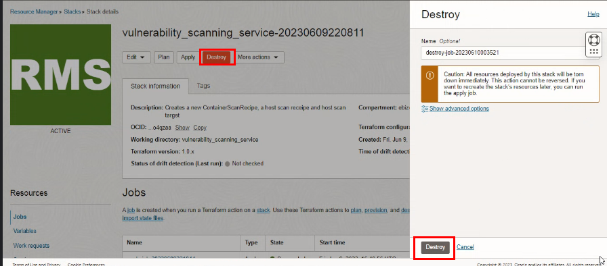
# END #

